**Chapter 46 - GRANDCHILDREN: 1998**

Sandi had two beautiful daughters born to her and David Nix, **JaNae & Chelci.**

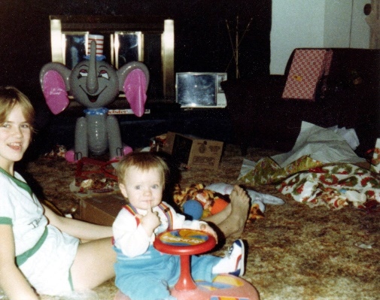**JANAE:**

**JaNae** was our first grandchild, and what a beautiful little girl she was. I was a young grandmother, but I loved it. Jeff is almost two years older than JaNae, so he was a “young uncle” We were living in Mesa, Arizona when JaNae was born, so I took Jeff with me and we flew up to be with this family so I could help Sandi with JaNae, which I loved doing, and help with the meals, laundry, housework, etc. Sandi wouldn’t let me do a lot. Friends, family and members of her ward brought in meals so I didn’t have to do much there. JaNae is a beautiful little girl and it was hard when I had to leave them. We were only in Arizona for 9 months as it didn’t work out financially for us there, so Ken was offered the job of being the Grantsville Farm Manager. I was happy to be back with family in Utah and especially happy to live close to Sandi, Dave and JaNae. Shellie, Mike, David & Scott were excited to be uncles and they loved her too. I would tend JaNae at times and I enjoyed it. I would sing to her, read her stories or tell her stories of the “Three Bears and Goldilocks”, “The Three Little Pigs”, “Red Riding Hood” and others. I have told those stories to all our children, and I think all our grandchildren.

**CHELCI:**

**Chelci** was born about five years later and I was happy to be living here in Grantsville, so I could see that beautiful little granddaughter, our second grandchild. She had dark hair, while JaNae was blond. They had different personalities, but both so cute. I was happy to be living close by so I could tend JaNae while Sandi was in the hospital and be able to see and tend Chelci also.

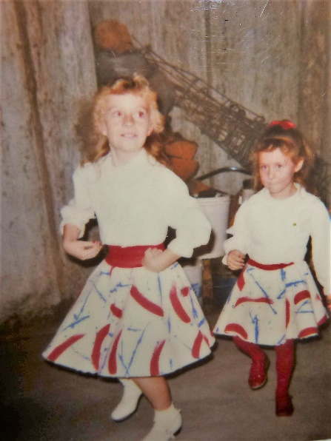Chelci has a allergy to the sun, and would get faint, so couldn’t play softball or tennis very long. She had to be careful.

Chelci has always had a beautiful voice from the time she was young, and I always loved listening to her.

The years go by so fast and now the girls were old enough to take dancing lessons so Sandi signed up JaNae & Chelci for Clogging (a form of dancing). Later, Sandi helped teach as she has always had a talent for dancing. She later took over the studio when the owner wanted to sell it. JaNae was a “natural” at this dancing, like her mom, and she had such a beautiful smile. Chelci was a cute dancer too. Ken and I loved to attend their dance recitals and competitions. They competed at Lagoon and Sandi, the girls and the others girls in Sandi’s dance class stayed at our home the night before the competition and then we all went to Lagoon together the next morning. After the competition, we would go on some of the rides.

The girls played softball and Ken and I would go and watch their games whenever we could. As Chelci began singing at various church and community events, we would go there also and we always enjoyed hearing her sing. She has such a beautiful voice.

. I would invite the girls to come stay with us for a week in the summer, when we had moved to Layton. We would make cookies, go to the park and go swimming, I loved these sweet and beautiful little granddaughters. I love being a mother, but I sure love being a grandmother also.

JaNae and Chelci were both cheerleaders in high school and both were in beauty pageants. Ken and I went to watch them cheerlead, and went to their beauty pageants. They both were beautiful in their gowns and their talents were so great, as they are both so talented with dance and Chelci with singing. Sandi always helped them with their gowns, hair styles, and their talent. With Sandi being talented with art, she made the props for them. **When JaNae was asked in the Miss Grantsville Pageant, “Who has influenced your life the most?” She said “My mom, she has always been there for me.”** That really touched Sandi, and I was thankful JaNae said that. JaNae’s dad and grandparents were there and they didn’t like her comment.

.

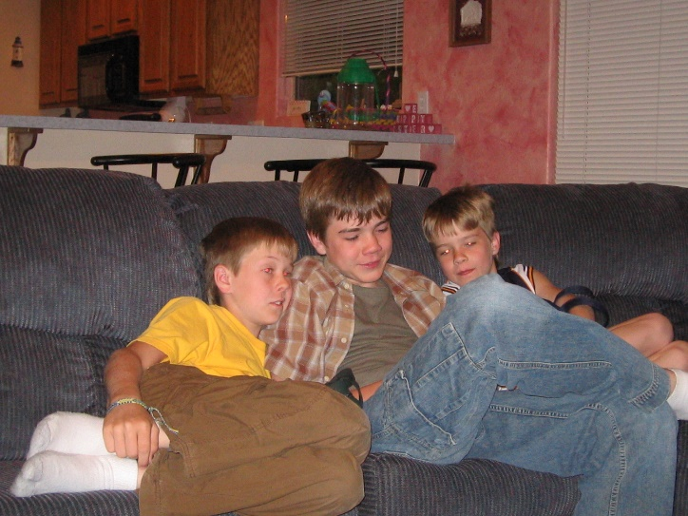Shellie & Roy have three such well-behaved & bright sons, **Garrett, Quint and Kevis**. When we go down to visit them, usually once or twice a year, we join with them in kneeling for family prayer both night and morning. We joined with them in reading scriptures each night before bedtime, and we joined with them in Family Home Evening each week. They took turns giving prayers, conducting, giving the lesson, preparing the refreshments and planning games or other activities. I am amazed at the questions and comments they make. They are being taught well and are special children. Shellie, takes the lead in seeing that these things happen, and Roy is not always with them as he is doing projects, working late or sleeping in, etc. Shellie struggles with this, and we wish he was more spiritual, but he is a good man and a good provider. Shellie has the boys do chores too, which is teaching them the value of work. Since Roy is a good provider, they go on trips, buy fun vehicles, games, etc., and have beautiful homes. I, and sometimes, Ken, have gone down to be with the boys while Shellie & Roy take vacations and that has been fun getting to be with these grandsons which we don’t see as often as our grandchildren in Utah.

**GARRETT:**

Garrett was our oldest grandson, and Ken and I were excited when we got the news that he was born. Shellie had had such a hard delivery. The hospital wasn’t good and the doctor was terrible. He let Shellie tear, instead of cutting her, and she hemorrhaged so bad that, if I remember correctly, they had to give her blood. When I saw her, she was so pale and weak. I flew down and because Shellie was so weak, I stayed an extra week to take care of her and help with the baby, meals, laundry and house. I remember one morning, both Garrett & Shellie were sleeping, so I decided to go for a short walk as the weather was so beautiful. I walked around the block. They were living in an apartment and it wasn’t in the best neighborhood – they were auto body shops, etc. When I got back, Shellie was awake. She said “Mom, you can’t walk in this neighborhood, it isn’t safe. I was worried about you.” Ken and Sandi drove down later and they loved seeing and holding little Garrett. They stayed for a few days and then I rode home with them. I still hated to leave Shellie as she still wasn’t up to par.

Garrett was a smart child and as he grew, he did really well in school and was really dedicated. He was a handsome young man and he was social, so he had lots of friends. Garrett has always been a wonderful son and grandson.

Ken and I went down for Garrett’s graduation from High School. He did really well and got a four-week scholarship to Arizona State University (ASU), but he will defer it to use after his mission. With his birthday in August, he doesn’t have to wait long to go on his mission. We also went down for his mission farewell. His talk was wonderful at their Sacrament Meeting, he will be an excellent missionary. I helped Shellie make food for family & friends after Sacrament meeting, and many came to wish him well. He is going to Kennewick, Washington. That is where Irven & Sandy’s son, Doug and his family live so he will be able to see them. Garrett will drive home with us and stay with us the night and we will take him to the Provo Mission Center. Garrett’s other grandparents, Veldon & Patsy Seymore were just returning from their mission at Martin’s Cove in Wyoming, so they met us here and went down with us also. We sure enjoyed being with Garrett and when we got to the MTC in Provo, we walked around and took pictures of both grandparents with Garrett. We were also able to go to the orientation meeting with Garrett and then hug him goodbye. We are good friends with Veldon & Patsy, so it was good being with them also. He was a wonderful missionary and Doug and Karen invited him and his companion to their home for meals and enjoyed meeting him. Ken and I went to Arizona again when Garrett returned home from his mission, and heard him give his talk to his ward. It was wonderful and we felt the spirit.

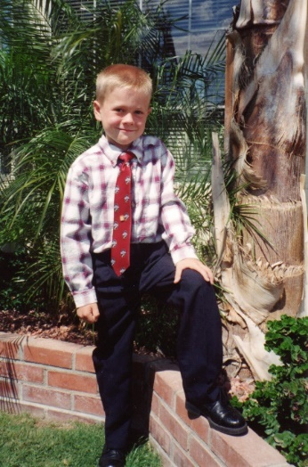

**QUINT:**

Quintwas such a cute little blond boy, and we were excited to have another grandson. Shellie, Roy & family would come up to our home in Layton for Christmas for three or four years, until it got too hard to bring all of them, plus the Christmas gifts. We loved having them come and Mike, Becky and their two children, David and Taylor Paige would also come, plus David and Shauna and little Tyler. Scott was on his mission, but Mishelle would come join us and we could call Scott and all of us take turns talking to him. Then we would open our presents, and **the best part for me was watching the excitement on the faces of these special grandchildren. Quint was one of the cutest – he would get so excited and jump up and down and I loved watching him.** We would then have breakfast and it always included eggnog with sprite in it. Those were such fun Christmases.

Quint at one time, when he was young, had a hard time waking up to get ready to go to school, so when I was going to be with the boys while Shellie & Roy went on a vacation with other couples, Shellie told me that Quint was hard to wake up, and she was right. I would try to wake him by singing “Good Morning” to him, by shaking him, and finally by dragging him off his top bunkbed and practically dressing him. One night I told him that it was in his mind, and if he told himself that he could wake up, then he would be able to. The next morning, I was surprised to see him by my bed saying “It worked, Grandma, I woke up”. The only problem was that it was five am. I told him that was great, but it was too early so he could go back to sleep for a couple of hours. I think from then on, he woke up easy, and I was sure glad.

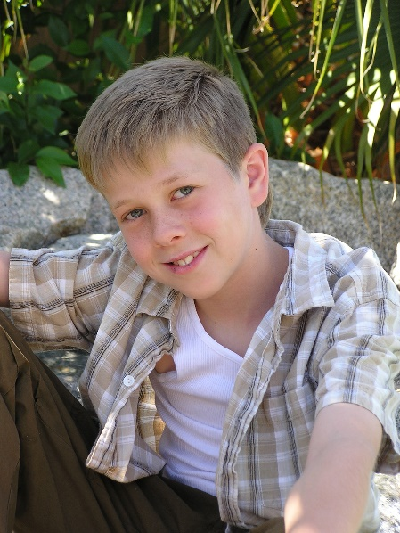Another cute memory I have of Quint was another time when I was staying with them. Ken couldn’t come as he had to work, so Shellie & Roy gave me the money to fly down. I had done lots of fun things that week with all the boys, and I enjoyed getting to know them better. The boys had Legos and other building equipment – erecter sets, and such, and they were really creative and talented and I was amazed at how well they played together and all the things they built together. Well, the day before their parents were to come home, Quint asked me if he could go play with his friends. I told him that since this was the last day, that I would be with them, I was hoping we could play more games or go someplace fun. He looked at me and said: “You know Grandma, that when company comes to visit, you are excited to see them…but after a while…… I said “Okay, Quint, you can go play with your friends.” I understood and knew he needed to go play with his friends, not just stay home with me. I thought it was pretty cute and funny, but when I told Roy & Shellie, Roy was upset that Quint would say that to me. I told him that I wasn’t offended and he was so cute about it.

As Quint grew older, he and Kevis became such good friends and did so much together. Garrett would be off with friends, now that he was that age, and I think because Garrett was so good at everything, Quint and Kevis felt they couldn’t measure up to Garrett. I wish they hadn’t felt that way, as they both have so many great talents and abilities too. We are all different and that’s the way it’s supposed to be.

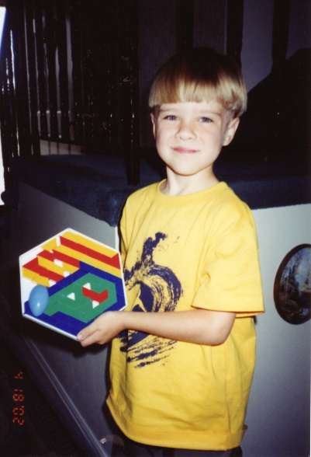**KEVIS:**

Kevis was also such a cute grandson. I remember when, we were visiting this family one year, Kevis was about three or four, and he was pretending to be a little dog and we put a collar on him with a leash, and I would walk around the house with him. He would be on his hands and knees and he was so cute.

Another time when they were visiting us and we all went to Lagoon. That is all except Ken as he doesn’t like Lagoon. Sometimes he would come later and have dinner with us and then we would all walk around in Pioneer Village and get an ice cream cone. Anyway, we were all standing in line to get on a ride and Shellie said: “Where is Kevis?” He might have been three years old. We all looked around and were panicked and all of us started calling him and looking all over. That is a scary place to lose a young child. Finally, we found him, and boy were we all relieved.

As Kevis got older, he was strong. We were swimming in their pool when they lived in Chandler and I was splashing him and trying to dunk him. He might have been 8 or 9, and boy he was dunking me and he even hurt me some, although I know he didn’t mean to, we were just having fun, but I was amazed at how strong he was.

Kevis has a low self-esteem, and I’m not sure why, as he is a good-looking boy too and very talented. When he was in grade school, I would walk to school with him, when I was staying with them and his parents were on vacation. I would hear a friend call over to him, but he usually didn’t acknowledge him. He didn’t play with other boys, even though he could have. He just liked being with Quint, or by himself.

When Kevis was a scout and went to scout camp, they played a game of hide & seek. Kevis went too far and got lost. The boys told their scout master that they couldn’t find Kevis, so they all went back out looking for him. When it got dark and he was nowhere to be found, the scout master called their Bishop and the Bishop called Shellie and Roy. They were so worried. Roy and his sons went with others of Roy’s family up to the scout camp in the mountains. The “Search & Rescue” was called in. When word got out that a scout was lost, many others joined the search. Shellie called Ken and I about 10 pm. We were asleep, but I heard the phone and got up. When I heard Shellie’s voice, I knew something was wrong. She called to ask if we would pray for Kevis that he would be found safe. I didn’t want to wake Ken as he had been working hard all day and was so tired. I couldn’t sleep, I just kept praying and worrying. I told Shellie to let me know if they heard anything. Shellie went with her sister-in-law’s up to the scout camp as she couldn’t just stay home and just wait for a call. The search went on all night. She called me crying and said they still couldn’t find him. It was cold there in the mountains and all Kevis had on was a light jacket. There were bears and cougars in those mountains. The Search & Rescue helicopters finally quit for the night and said they would resume looking for him at first light. I told Ken early the next morning and then called our children to tell them. I had told Shellie that we and probably her siblings would come and help look for him, but she said “No”, that it was too far for us to come and there were tons of people there looking for him. When I told our sons, they all said “We don’t care what Shellie said, we are going, Kevis is our nephew and Shellie is our sister. Sandi told her brothers that they were not going without her, so they all met at Mike and Becky’s and Mike, David, Scott, Jeff and Sandi headed for Arizona. I called Shellie and told her that her siblings were on their way. She got emotional and was touched at their love and concern for her, Roy & Kevis. About noon, the helicopter spotted Kevis. He had made an SOS out of rocks. He had been so thirsty that morning that he drank some yukky water that he found in a small pond or something. He was very grateful to be rescued. The news camera’s and reporters were there talking to Kevis and his parents. Shellie heard the captain of the search & rescue say to others that since it had been that long, he didn’t expect to find Kevis alive. Shellie was glad she didn’t hear that before he was found. Shellie called David to tell them that Kevis was found, and to express her love and gratitude for them coming. They had got as far as Beaver. They were grateful he was found, but sorry they couldn’t have been there to help with the search. They turned around and came home. We were all so relieved to hear that he was safe and sound. I can’t imagine what went through Kevis’s mind as he was alone in the forest that night. I’m sure he must have been really scared as he heard animal noises and with it being so dark and cold.

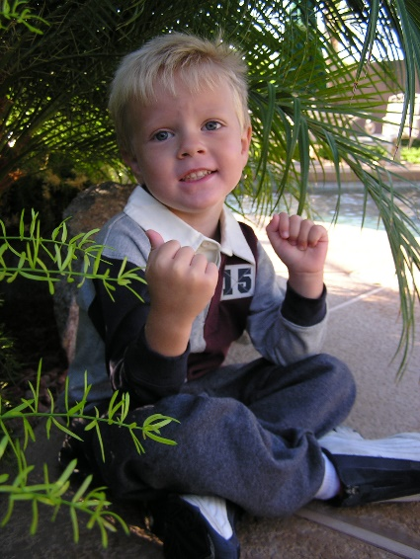J**ASE**:

I was down visiting soon after Jase was born, and I remember going to the hospital or doctor’s office for him to get his shots. When they gave him so many shots, I felt sick and was worried that a baby shouldn’t have that many shots, but I didn’t feel I could do anything about it. They diagnosed Jase a few years later with have “Asperger’s”, that is a milder form of “Autism”. Jase is such a sweet boy and we all love him very much.

I remember one time when we were down visiting, I would watch him jumping on their trampoline. He loved to do that and he would talk to himself as he jumped or ran around the trampoline. I would jump with him sometimes too. He had two twin cousins, and he would play with them sometimes, and he did have a good friend, when he was young, but that family moved and that was sad. After that, because Jase doesn’t have social skills because of the Asperger’s, most kids at church and school just ignore him as they don’t know what to say or do around him. I have felt bad about that as he is such a sweet boy.

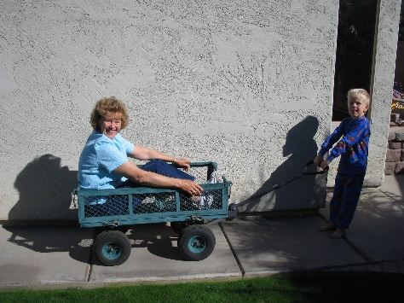One time when we were down visiting, they had a large wagon and I would get in the wagon and Jase would pull me around.

As Jase grew older, he got an RC plane for his birthday or Christmas. They had a park close by and he would go there to fly his plane. Ken and I went with him one day and he was really good at flying it. He did have a friend there, who lived by the park, and sometimes he would come and watch Jase fly it and I think Jase would let him fly it.

**DAVID MICHAEL**.

When David was born, Ken and I were excited to go and meet this little grandson, so we went to the hospital and brought gifts. I asked Mike and Becky if I could hold him, and Becky said “Yes”. Mike looked at me as I picked David up and he said “Be careful, Mom, don’t drop him.” I thought that was funny since I have had six babies and tended other grandchildren when they were babies, plus I started baby sitting when I was ten years old, since I had been a second mother to my siblings.

Mike and Becky were both going to BYU. They were living in a cute furnished apartment which Becky’s dad and mon owned and let them live there while going to college. That made it a lot easier, since they were both going full time, and Mike was working part time. I was amazed at how well Mike and Becky managed their time, so that when David was little, they worked it out so that one of them was with David, and that way they didn’t have to pay a baby sitter or put him in day care, and it was better to have a parent with him anyway, as they love him and others don’t the way parents do.

**TAYLOR PAIGE:**

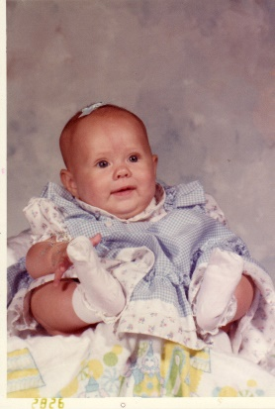Taylor was such a cute Rolly Polly little doll. Her chubby cheeks, you just wanted to kiss. She has always been a sweet, wonderful granddaughter. Her and David have always been great friends. I don’t remember them arguing or fighting, but, of course, I wasn’t always around them. Taylor was a good-natured baby, as I remember. She was born just before Mike graduated from BYU with a double degree. One in special education and the other a teaching degree. We loved tending Taylor and David as they were so cute and so fun.

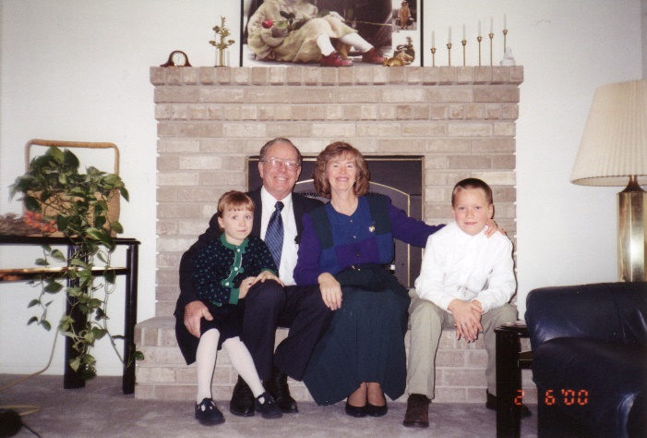We enjoyed **David & Taylor**. They are such cute grandchildren - so well behaved, bright and fun to be with. Mike & Becky are doing a good job of raising these children. Sometimes I feel Mike is too strict on them, but he loves them and both he & Becky teach them what's right and set a good example for them and are good parents. We are proud of them

Ken and I would go down to Provo, where they were living, and tend the children while Mike & Becky went on a trip together. David had a trike, which he rode, and a wagon. We would put Tayler in the wagon and we would all go for a walk/ride around the block. They had a nice big set of Legos with a table made for Legos and we would build different items and have fun together. I would read stories to them and I taught them to play “Old Pig” with Flinch cards, when they were old enough to play that game, which they can learn that at a pretty young age, as it isn’t hard and is fun for all. When we would go camping as a family, I remember taking David to go on a walk and as we walked down the path, I taught him the song, my dad taught me. “Tramp, Tramp, Tramp, Tramp.” We tramped along as we sang that song.

David was about this age (the picture) when my mother passed away. We had a picture of Mom on the stage with plants and flowers from the funeral, when we were all eating the lunch that the Relief Society sisters had provided. I remember David going over to the picture and looking at this picture of his Great Grandmother, and he was sad. I treasured that moment.

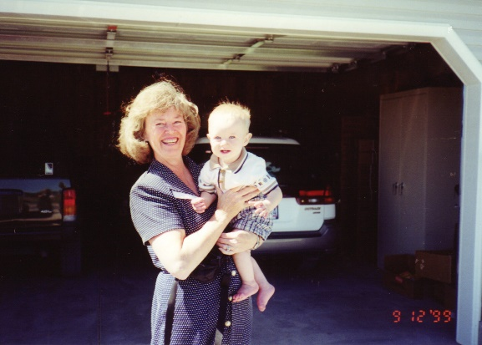**TYLER:**

David & Shauna had a beautiful baby son, **Tyler**, born on Oct. 28, 1998. We are enjoying him. David & Shauna are sure happy with him and are wonderful parents. They lived in Idaho Falls at the time and David was a pharmaceutical Representative. We enjoyed going there to stay with them for a few days. I loved holding little Tyler and being with this special family. We missed having them living close by.